Safer Internet Day
  - Social media plan – Issue 1, January 2021

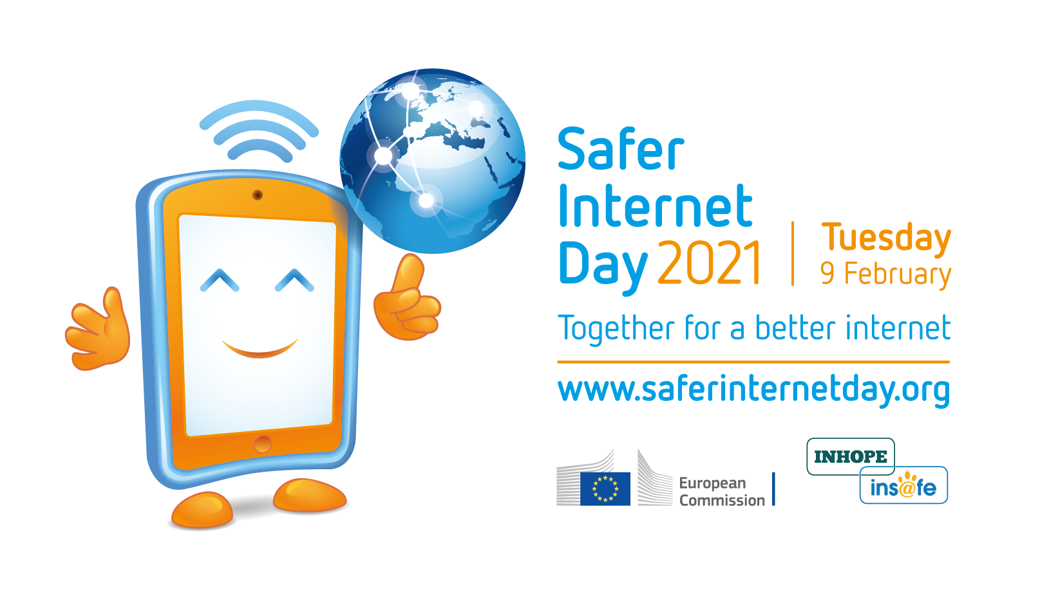

Campaign | Safer Internet Day (SID) 2021
Promotion period | From Monday, 11 January 2021 to Saturday, 13 February 2021
Campaign hashtags | #SaferInternetDay and #SID2021
Target audience | Children, teenagers, parents, carers, teachers, educators, civil society organisations, industry representatives, policy makers, media representatives, researchers, and more!

Together for a better internet on Safer Internet Day (SID) 2021!
Each year on Safer Internet Day, millions of people join forces "Together for a better internet" to inspire positive change online, raise awareness of online safety issues, and participate in activities across the globe.
With one month to go until the 2021 edition, taking place on Tuesday, 9 February 2021, we would like to invite you to join the movement and help us ensure the internet is a place of opportunities for children and young people where they can create, engage and share positively and freely.
This social media plan provides a few tips and ideas on how you can amplify the campaign’s key messages through your own dissemination channels. Please feel free to tailor them to your own needs!

In this plan…

- Website article (p. 3) – A short and long version of an overview article about Safer Internet Day, which you are welcome to publish on your own website/blog, adapting as needed.
- Social media channels and assets (p. 5) – An overview of the main social media channels used for the campaign, and of some assets you may use to show your support for SID on these platforms.
- Dissemination timeline (p. 7) – A breakdown of the timeline for dissemination of SID campaign messages on social media.
- Social media messages (p. 8) – A collection of suggested social media messages which you may post to your respective channels or adapt and translate as needed.
- Social media visuals (p. 11) – A set of suggested social media visuals which you are welcome to use to accompany your posts.

Website article

Please find below a short and long version of an overview article for Safer Internet Day. You are welcome to publish these or adapt them as needed, perhaps inserting some information about your own planned actions.
Please look out for additional articles and press releases closer to the day. These will be published on www.saferinternetday.org and www.betterinternetforkids.eu and disseminated via our social media channels.

Short article
Safer Internet Day (SID) is fast approaching – on Tuesday, 9 February 2021, we will be millions around the globe, joining forces “Together for a better internet”. How do you plan to participate in the big day?
Every February since 2004, Safer Internet Day (SID) – organised by the Insafe/INHOPE network of European Safer Internet Centres (SICs) with the support of the European Commission* – has been a global, community-led observance which provides a space for all stakeholders to reflect on how together we can promote a responsible, respectful, critical and creative use of digital technologies with the ultimate goal of fostering a better internet for all.
While we recognise that celebrations may look a little different this time around as we adapt to COVID-19 constraints, we hope that SID 2021 will still be a vibrant and engaging celebration, allowing us all to reflect on our increased use of digital technologies as a result of the pandemic.
In the meantime, make sure to:
- visit www.saferinternetday.org to get an idea of how our SID committees and supporters are celebrating SID 2021, and to find a variety of resources and inspiration for your own plans.
- and keep an eye on the official Safer Internet Day Twitter and Facebook pages.
* Safer Internet Day would not be possible without the support of the European Commission. Currently the funding is provided by the Connecting Europe Facility programme (CEF). Find out more about the EC’s “European Strategy for a Better Internet for Children” on the European Commission’s website.

Long article
Digital technologies provide us with a world of possibilities at our fingertips. Never before have we enjoyed so many opportunities to learn, exchange, participate and create. In 2021, this statement rings truer than ever: in the past year, we have collectively taken a digital leap, and digital means of communication have proven nothing short of vital for our societies to keep functioning in the face of a global health crisis.
However, greater internet use also means greater exposure to online risks, especially for the youngest among us. Concerns pertaining to cybercrime, privacy, misinformation and disinformation, hate speech, cyberbullying, exposure to harmful content and predatory behaviours have grown since the advent of the coronavirus crisis.
As internet users, we are all faced with the same dilemma: how do we make the most of the opportunities the digital environment brings us, while at the same time mitigating any potential negative side-effect it might entail?
Every February since 2004, Safer Internet Day (SID) – organised by the Insafe/INHOPE network of European Safer Internet Centres (SICs) with the support of the European Commission* – is a global, community-led observance which provides a space for all stakeholders to reflect on how together we can promote a responsible, respectful, critical and creative use of digital technologies with the ultimate goal of fostering a better internet for all. Having grown in scope over the years, Safer Internet Day is now celebrated by children, young people, parents and carers, teachers, educators and social workers, industry, decision makers and politicians from over 170 countries.
On Safer Internet Day 2021 – on Tuesday, 9 February 2021 – we will be millions across the globe, joining forces “Together for a better internet”. While we recognise that celebrations may look a little different this time around as we adapt to COVID-19 constraints, we hope that SID 2021 will still be a vibrant and engaging celebration, allowing us all to reflect on our increased use of digital technologies as a result of the pandemic.
In the meantime, make sure to:
- visit www.saferinternetday.org to get an idea of how our SID committees and supporters are celebrating SID 2021, and to find a variety of resources and inspiration for your own plans.
- and keep an eye on the official Safer Internet Day Twitter and Facebook pages.
* Safer Internet Day would not be possible without the support of the European Commission. Currently the funding is provided by the Connecting Europe Facility programme (CEF). Find out more about the EC’s “European Strategy for a Better Internet for Children” on the European Commission’s website.

Social media channels and assets

Main SID social media channels

Facebook - @SaferInternetDay
Please feel free to share, like and comment the SID-related messages we regularly post on the Safer Internet Day Facebook page. Do you have anything exciting to share about SID 2021? Tag us using @SaferInternetDay and we will aim to give your post some engagement.

Twitter - @SafeInternetDay
Please feel free to tweet using the campaign hashtags #SID2021 and/or #SaferInternetDay and retweet our SID-related tweets as often as possible. Remember to tag us using @SafeInternetDay in your tweets so that we can retweet you as well!

Overview of the SID social media assets – more coming soon

In the coming weeks we’ll be releasing a range of exciting assets which you can use to support Safer Internet Day 2021 actions – simply go to the “Join SID” section on www.saferinternetday.org to have access to the SID logos, the promotional video, a range of GIFs for social media, the key messages to share on SID 2021, and more – keep checking back regularly for the latest updates!
In the meantime, here is what you can do to show your support for SID on social media:
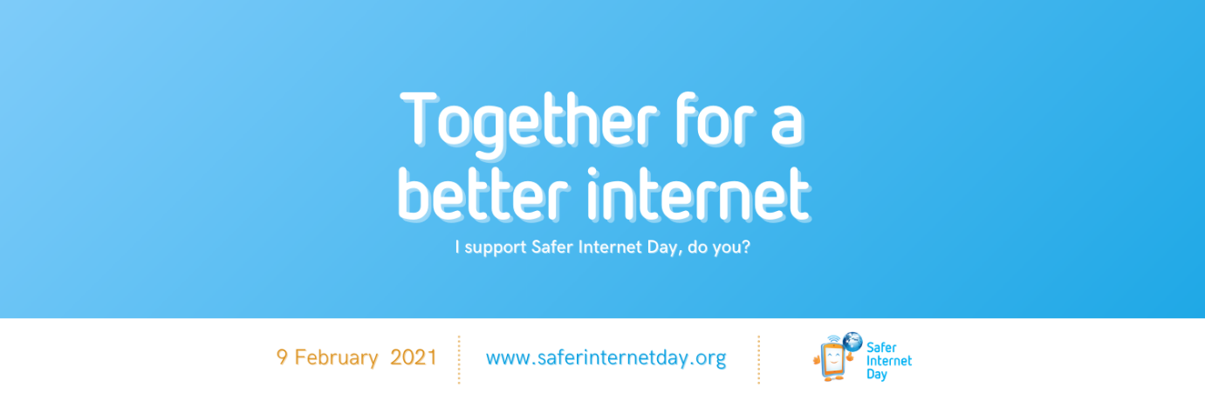
- Opt for a SID cover for your Twitter and Facebook profiles. Download the cover illustrations at www.saferinternetday.org/join
- Add a SID Twibbon to your Facebook and Twitter profile pictures. Set it up at http://www.twibbon.com/support/safer-internet-day-2021
- Use our SID frame for your Facebook profile picture. Add it now on Facebook
- Last but not least, watch the SID promotional video on YouTube and share it with your own audiences !
Click the screenshot to play the video

Dissemination timeline

Safer Internet Day key messages | From Monday, 11 January 2021 to Tuesday, 9 February 2021 | Help us disseminate the key messages of the Safer Internet Day campaign | These messages are featured in the present SID social media plan
Safer Internet Day top tips | From Monday, 25 January 2021 to Tuesday, 9 February 2021 | Help us disseminate online safety tips and advice | These messages will be featured in issue n°2 of the SID social media plan
Final countdown to Safer Internet Day | From Tuesday, 2 February 2021 to Monday, 8 February 2021 | Help us raise awareness of the fast-approaching Safer Internet Day | These messages will be featured in issue n°2 of the SID social media plan
D-Day! | On Tuesday, 9 February 2021 | Help us make some noise about Safer Internet Day, on the day itself | These messages will be featured in issue n°3 of the SID social media plan

Social media posts

On Twitter

- On Tuesday, 9 February 2021, for #SaferInternetDay, we'll be millions, joining forces around the globe, "Together for a better internet"! And you, how will you get involved in #SID2021? Get inspired at www.saferinternetday.org

- This #SaferInternetDay, let's reaffirm that decision makers are in a prime position to create a safer and better internet by providing a culture in which everyone - especially children and young people - can thrive online while remaining safe. www.saferinternetday.org

- Children and young people deserve to grow up in a digital environment where they can create, engage, access opportunities and share freely and positively. For #SaferInternetDay, find ways of supporting them at saferinternetday.org/resources

- #SaferInternetDay is just around the corner and we’ll be playing our part for a better internet! Find out more about other supporters’ exciting #SID2021 plans in your country now at saferinternetday.org/in-your-country

- 👨‍👩‍👧 Parental influence, guidance and education have the potential to empower children to use technology responsibly, respectfully, critically and creatively.

➡️ Parents and carers, visit www.saferinternetday.org to find out how you can play your part in #SaferInternetDay!

- No matter where you are, you can celebrate #SaferInternetDay in your own way. Find out what's happening on #SID2021 in our country – visit saferinternetday.org/in-your-country

- #Teachers, in these times of remote learning, how are you supporting your pupils' digital and media literacy? This #SaferInternetDay, why not empower them to make the right choices online? To do so, discover some #SID2021 educational resources at saferinternetday.org/resources

- Tech companies are in direct position to shape the online services which we interact with on a daily basis. In doing so, they have the power to make a better and safer internet a concrete reality. Find out which company supports #SaferInternetDay at saferinternetday.org/supporters

- Show your support and help us spread the word about #SaferInternetDay – add a Twibbon to your profile picture now! bit.ly/SID2021_Twibbon

- 🤔 Curious about who'll be celebrating #SaferInternetDay with us on 9 February 2021 and how?

👉 Discover industry partners, institutions and other organisations committed to creating a better internet for everyone at saferinternetday.org/supporters

On Facebook

- On Tuesday, 9 February 2021, for @SaferInternetDay, we'll be millions, joining forces around the globe, "Together for a better internet"! And you, how will you get involved in SID 2021? Get inspired at www.saferinternetday.org

- This @SaferInternetDay, let's reaffirm that decision makers are in a prime position to create a safer and better internet by providing a culture in which everyone - especially children and young people - can thrive online while remaining safe. www.saferinternetday.org

- Children and young people deserve to grow up in a digital environment where they can create, engage, access opportunities and share freely and positively. For @SaferInternetDay, find ways of supporting them at saferinternetday.org/resources

- @SaferInternetDay is just around the corner and we’ll be playing our part for a better internet! Find out more about other supporters’ exciting SID 2021 plans in your country now at saferinternetday.org/in-your-country

- 👨‍👩‍👧 Parental influence, guidance and education have the potential to empower children to use technology responsibly, respectfully, critically and creatively.

➡️ Parents and carers, visit www.saferinternetday.org to find out how you can play your part in @SaferInternetDay!

- No matter where you are, you can celebrate @SaferInternetDay in your own way. Find out what's happening on SID 2021 in our country – visit saferinternetday.org/in-your-country

- Teachers, in these times of remote learning, how are you supporting your pupils' digital and media literacy? This @SaferInternetDay, why not empower them to make the right choices online? To do so, discover some SID 2021 educational resources at saferinternetday.org/resources

- Tech companies are in direct position to shape the online services which we interact with on a daily basis. In doing so, they have the power to make a better and safer internet a concrete reality. Find out which company supports @SaferInternetDay at saferinternetday.org/supporters

- I am a proud supporter of @SaferInternetDay, an international celebration marked by millions of people in over 170 countries worldwide on 9 February 2021. Show your support too! Add the SID 2021 frame to your profile picture: bit.ly/SID2021_Frame

- 🤔 Curious about who'll be celebrating @SaferInternetDay with us on 9 February 2021 and how?

👉 Discover industry partners, institutions and other organisations committed to creating a better internet for everyone at saferinternetday.org/supporters

Social media visuals
Images are a great way of grabbing followers’ attention and increasing engagement – for this reason, we have prepared a range of visuals to accompany your posts, which you can download at www.saferinternetday.org/join.
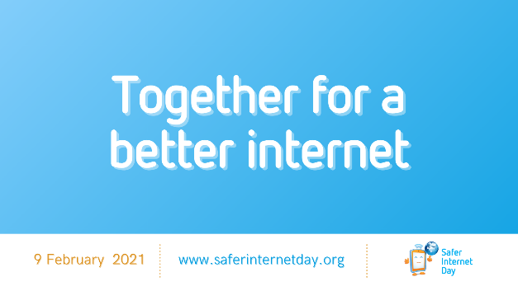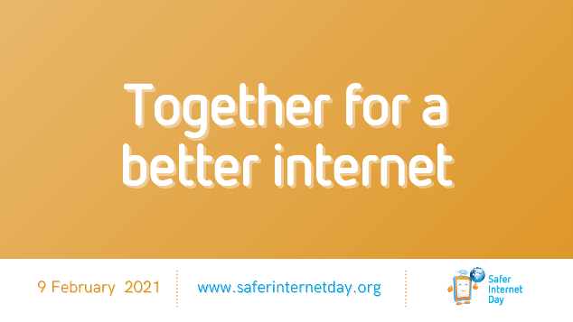
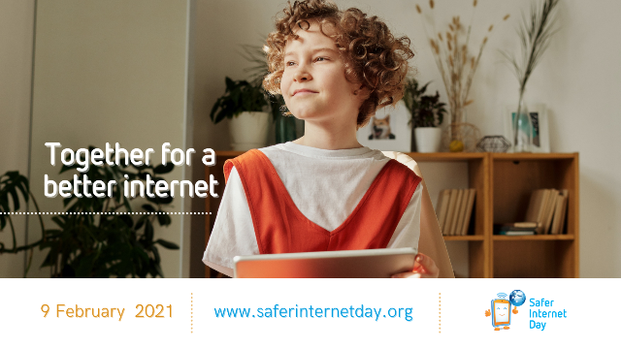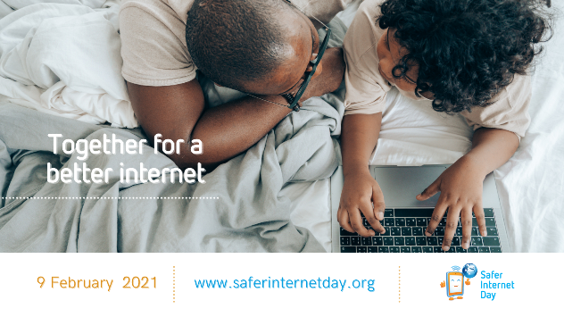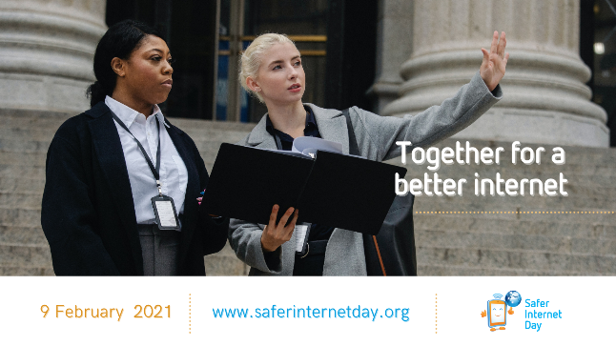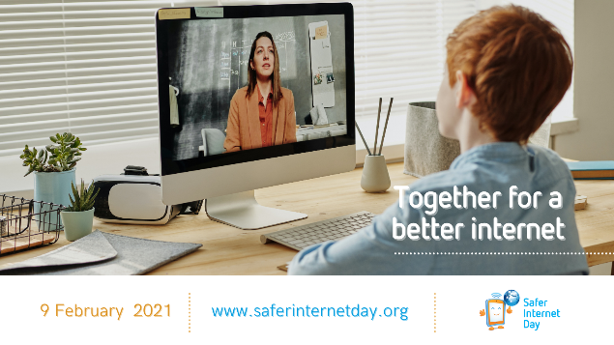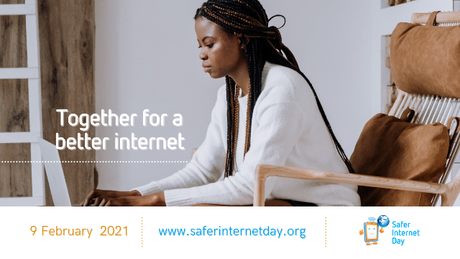

What’s next?
Keep an eye on www.saferinternetday.org for more SID 2021 promotional assets to use on your own channels, as well as issues 2 and 3 of the SID 2021 social media plan, to be released respectively on Monday, 25 January 2021 and Monday, 8 February 2021.
Many thanks from the SID Coordination Team for spreading the word about Safer Internet Day 2021. We are very much looking forward to seeing your plans unfold. Together for a better internet!

