Safer Internet Day
  - Social media plan – Issue 2, January 2021

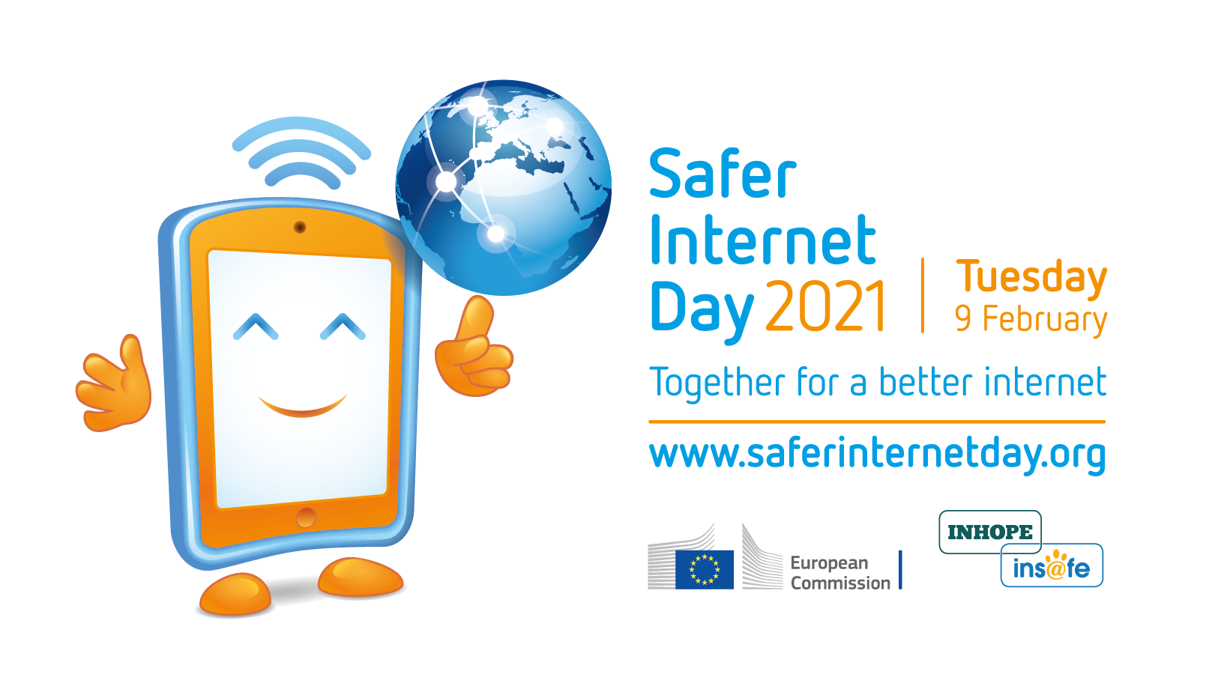

Campaign | Safer Internet Day (SID) 2021
Promotion period | From Monday, 11 January 2021 to Saturday, 13 February 2021
Campaign hashtags | #SaferInternetDay and #SID2021
Target audience | Children, teenagers, parents, carers, teachers, educators, civil society organisations, industry representatives, policy makers, media representatives, researchers, and more!

Together for a better internet on Safer Internet Day (SID) 2021!
Each year on Safer Internet Day, millions of people join forces "Together for a better internet" to inspire positive change online, raise awareness of online safety issues, and participate in activities across the globe.
With only two weeks until the 2021 edition, taking place on Tuesday, 9 February 2021, we would like to invite you to join the movement and help us ensure the internet is a place of opportunities for children and young people where they can create, engage and share positively and freely.
This social media plan provides a few tips and ideas on how you can amplify the campaign’s key messages through your own dissemination channels. Please feel free to tailor them to your own needs!

In this plan…

- Website article (p. 3) – A short and long version of an overview article about Safer Internet Day, which you are welcome to publish on your own website/blog, adapting as needed.
- Social media channels and assets (p. 5) – An overview of the main social media channels used for the campaign, and of some assets you may use to show your support for SID on these platforms.
- Dissemination timeline (p. 8) – A breakdown of the timeline for dissemination of SID campaign messages on social media.
- Social media messages and visuals (p. 9) – A collection of suggested social media messages and accompanying visuals which you may post to your respective Twitter (p. 9) and Facebook (p. 14) channels, adapting and translating as needed.

Website article

Please find below a short and long version of an overview article for Safer Internet Day. You are welcome to publish these or adapt them as needed, perhaps inserting some information about your own planned actions.
Please look out for additional articles and press releases closer to the day. These will be published on www.saferinternetday.org and www.betterinternetforkids.eu and disseminated via our social media channels.

Short article
Safer Internet Day (SID) is fast approaching – on Tuesday, 9 February 2021, we will be millions around the globe, joining forces “Together for a better internet”. How do you plan to participate in the big day?
Every February since 2004, Safer Internet Day (SID) – organised by the Insafe/INHOPE network of European Safer Internet Centres (SICs) with the support of the European Commission* – has been a global, community-led observance which provides a space for all stakeholders to reflect on how together we can promote a responsible, respectful, critical and creative use of digital technologies with the ultimate goal of fostering a better internet for all.
While we recognise that celebrations may look a little different this time around as we adapt to COVID-19 constraints, we hope that SID 2021 will still be a vibrant and engaging celebration, allowing us all to reflect on our increased use of digital technologies as a result of the pandemic.
In the meantime, make sure to:
- visit www.saferinternetday.org to get an idea of how our SID committees and supporters are celebrating SID 2021, and to find a variety of resources and inspiration for your own plans.
- and keep an eye on the official Safer Internet Day Twitter and Facebook pages.
* Safer Internet Day would not be possible without the support of the European Commission. Currently the funding is provided by the Connecting Europe Facility programme (CEF). Find out more about the EC’s “European Strategy for a Better Internet for Children” on the European Commission’s website.

Long article
Digital technologies provide us with a world of possibilities at our fingertips. Never before have we enjoyed so many opportunities to learn, exchange, participate and create. In 2021, this statement rings truer than ever: in the past year, we have collectively taken a digital leap, and digital means of communication have proven nothing short of vital for our societies to keep functioning in the face of a global health crisis.
However, greater internet use also means greater exposure to online risks, especially for the youngest among us. Concerns pertaining to cybercrime, privacy, misinformation and disinformation, hate speech, cyberbullying, exposure to harmful content and predatory behaviours have grown since the advent of the coronavirus crisis.
As internet users, we are all faced with the same dilemma: how do we make the most of the opportunities the digital environment brings us, while at the same time mitigating any potential negative side-effect it might entail?
Every February since 2004, Safer Internet Day (SID) – organised by the Insafe/INHOPE network of European Safer Internet Centres (SICs) with the support of the European Commission* – is a global, community-led observance which provides a space for all stakeholders to reflect on how together we can promote a responsible, respectful, critical and creative use of digital technologies with the ultimate goal of fostering a better internet for all. Having grown in scope over the years, Safer Internet Day is now celebrated by children, young people, parents and carers, teachers, educators and social workers, industry, decision makers and politicians from over 170 countries.
On Safer Internet Day 2021 – on Tuesday, 9 February 2021 – we will be millions across the globe, joining forces “Together for a better internet”. While we recognise that celebrations may look a little different this time around as we adapt to COVID-19 constraints, we hope that SID 2021 will still be a vibrant and engaging celebration, allowing us all to reflect on our increased use of digital technologies as a result of the pandemic.
In the meantime, make sure to:
- visit www.saferinternetday.org to get an idea of how our SID committees and supporters are celebrating SID 2021, and to find a variety of resources and inspiration for your own plans.
- and keep an eye on the official Safer Internet Day Twitter and Facebook pages.
* Safer Internet Day would not be possible without the support of the European Commission. Currently the funding is provided by the Connecting Europe Facility programme (CEF). Find out more about the EC’s “European Strategy for a Better Internet for Children” on the European Commission’s website.

Social media channels and assets

Main SID social media channels

Facebook - @SaferInternetDay
Please feel free to share, like and comment the SID-related messages we regularly post on the Safer Internet Day Facebook page. Do you have anything exciting to share about SID 2021? Tag us using @SaferInternetDay and we will aim to give your post some engagement.

Twitter - @SafeInternetDay
Please feel free to tweet using the campaign hashtags #SID2021 and/or #SaferInternetDay and retweet our SID-related tweets as often as possible. Remember to tag us using @SafeInternetDay in your tweets so that we can retweet you as well!

Overview of the SID social media assets

We have released a range of exciting assets which you can use to support Safer Internet Day 2021 actions – simply go to the “Join SID” section on www.saferinternetday.org to have access to the SID logos, the promotional video, a range of GIFs for social media, a SID 2021 infographic, the key messages to share on SID 2021, and more – keep checking back regularly for the latest updates!
In the meantime, here is what you can do to show your support for SID on social media.

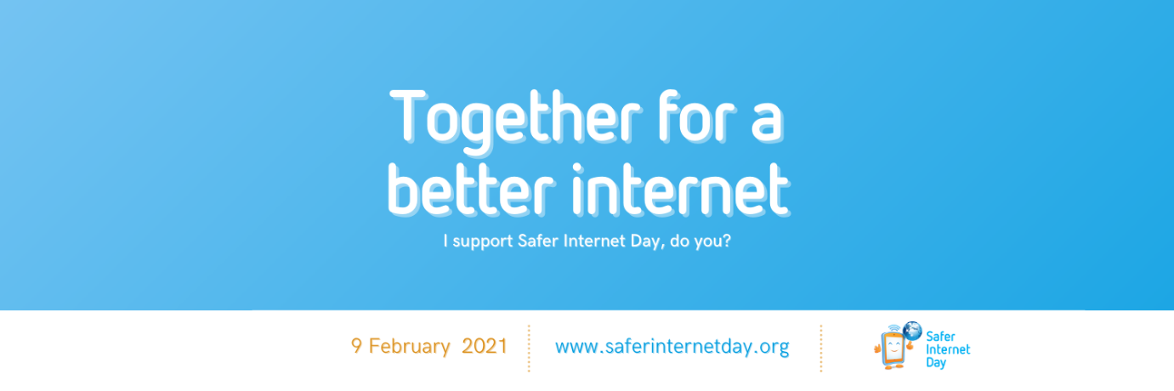
Safer Internet Day 2021 Twitter cover

Opt for a Safer Internet Day cover for your Twitter and Facebook profiles. Download the cover illustrations at www.saferinternetday.org/join

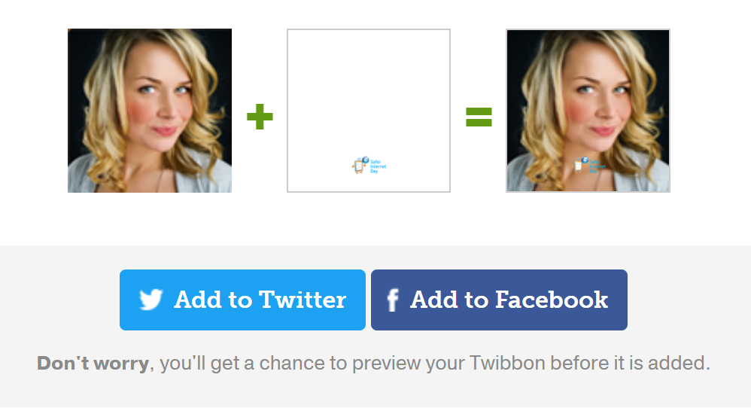
Safer Internet Day Twibbon
Add a Safer Internet Day Twibbon to your Facebook and Twitter profile pictures. Set it up at http://www.twibbon.com/support/safer-internet-day-2021

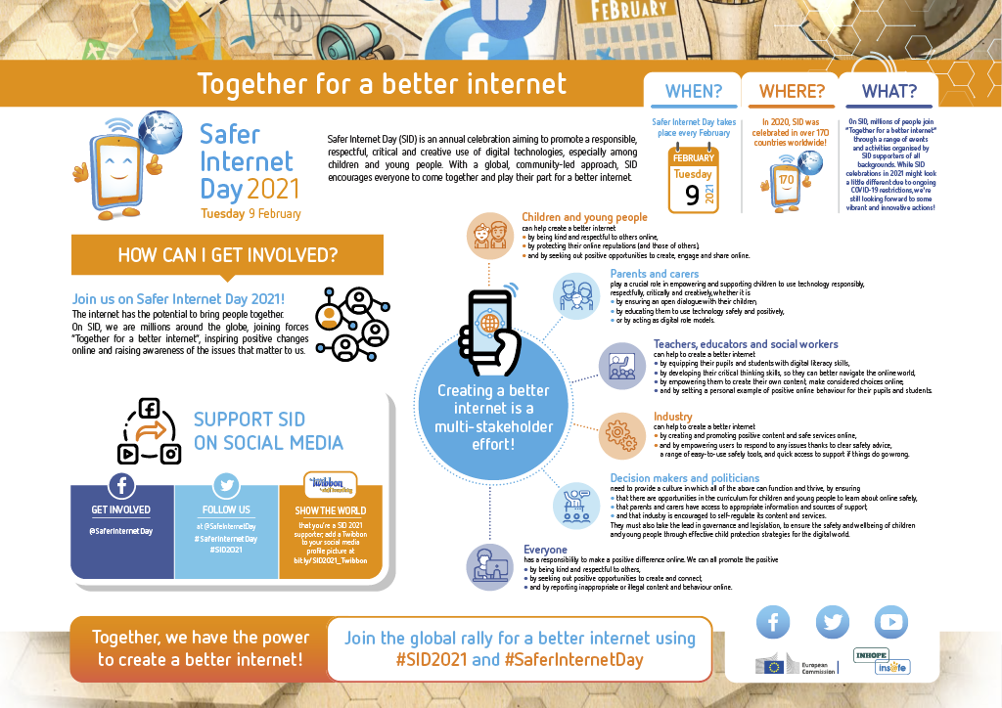
Safer Internet Day 2021 infographic
Have a look at the infographic summarising everything you need to know about Safer Internet Day 2021 and share it with your own audiences. View it in full resolution (PDF) here.

Click the screenshot to play the video

Last but not least, watch the SID promotional video – now containing subtitles in 25+ languages – on YouTube and share it with your own audiences.

Dissemination timeline

Safer Internet Day key messages | From Monday, 11 January 2021 to Tuesday, 9 February 2021 | Help us disseminate the key messages of the Safer Internet Day campaign | These messages were featured in issue n°1 of the SID social media plan
Safer Internet Day top tips | From Monday, 25 January 2021 to Tuesday, 9 February 2021 | Help us disseminate online safety tips and advice | These messages are contained in the present issue of the SID social media plan
Final countdown to Safer Internet Day | From Tuesday, 2 February 2021 to Monday, 8 February 2021 | Help us raise awareness of the fast-approaching Safer Internet Day | These messages are contained in the present issue of the SID social media plan
D-Day! | On Tuesday, 9 February 2021 | Help us make some noise about Safer Internet Day, on the day itself | These messages will be featured in issue n°3 of the SID social media plan, to be released on Monday, 8 February 2021

Social media posts

On Twitter

A – Dissemination of Safer Internet Day top tips
From Monday, 25 January 2021 to Tuesday, 9 February 2021
Suggested post | Accompanying visual
These past five years, #cyberbullying has been the most frequently reported issue to @Insafenetwork helplines.  This #SaferInternetDay, let’s join together for a better internet and put an end to it. bit.ly/3ofCHkV | 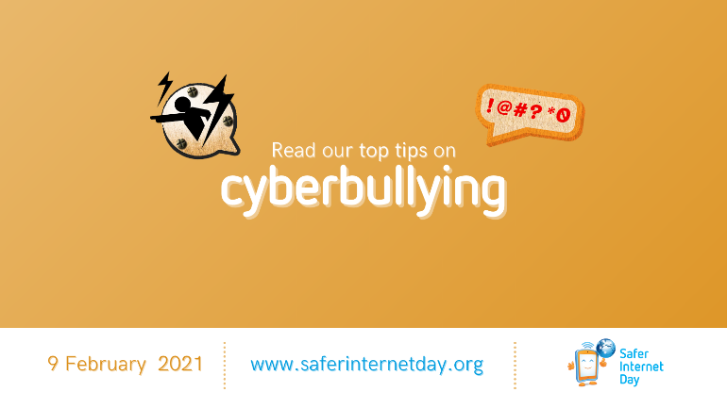  Image name: SID2021_Twitter_Cyberbullying
Too many children and young people encounter inappropriate content online, which risks harming their development.  With #SaferInternetDay coming up, there's no better time to dive into our explainer and resources on the topic: bit.ly/3c60ZeB | 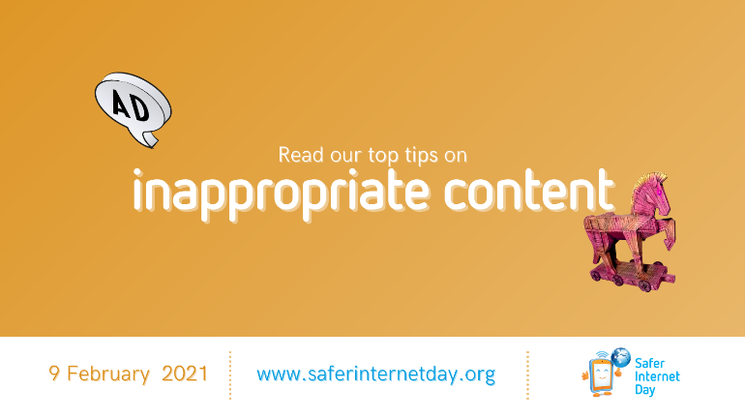  Image name: SID2021_Twitter_Inappropriate
In our ever-more digitalised societies, curating your online reputation is becoming imperative.  #SaferInternetDay is the perfect opportunity for you to learn how to do so like a pro!  Discover our topical explainer at bit.ly/3ohCEoG | 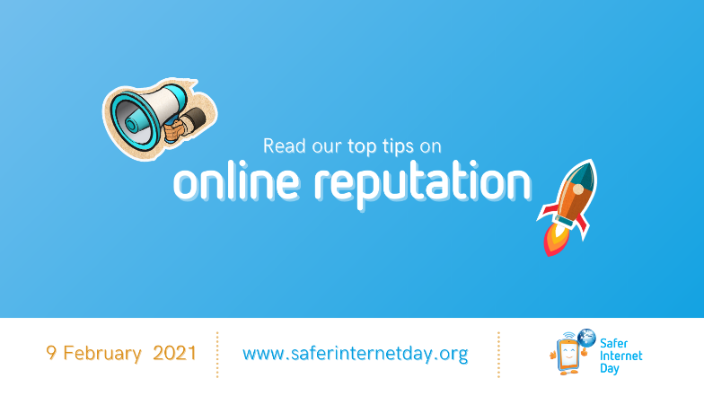  Image name: SID2021_Twitter_OnlineReputation
Sexting can pose a serious challenge to children and young people as it can potentially expose them to the non-consensual sharing of intimate images with a wider audience.  This #SaferInternetDay season, discover our safety tips at bit.ly/3qJnTN9 | Image name: SID2021_Twitter_Sexting
Sextortion refers to the sexual coercion and extortion of children and young people online, for predatory or financial motives.  With #SaferInternetDay approaching, now is the time to educate yourself on the topic and find some tips for dealing with it at bit.ly/3iHbyGh | Image name: SID2021_Twitter_Sextortion
There are many online challenges out there, and while most are fun and harmless, some have turned out to have tragic consequences.  As #SaferInternetDay is approaching, learn more about this phenomenon and the risks it poses in our topical explainer: bit.ly/3odBoD4 | 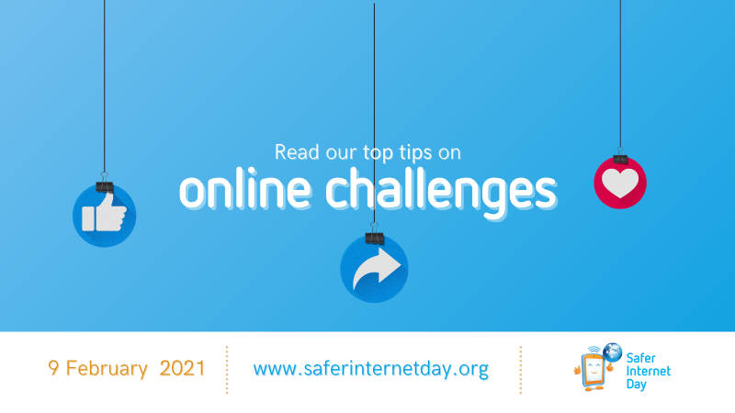  Image name: SID2021_Twitter_OnlineChallenges

B – Dissemination of Safer Internet Day promotional assets
From Monday, 25 January 2021 to Tuesday, 9 February 2021
Suggested post | Accompanying visual
On Tuesday, 9 February 2021, for #SaferInternetDay, we’ll be millions, joining forces around the globe, together for a better internet!  The #SID2021 promotional video is available with subtitles in 25+ languages – go watch it now at youtu.be/M03BJFjBM3w | YouTube thumbnail of the SID video
✅ What is #SaferInternetDay?  ✅ What does it stand for?  ✅ How can we all play our part for a better internet?  Find answers to all your questions in our #SID2021 infographic – view it in full resolution at (LINK) | Image name: SID2021_Infographic
#SaferInternetDay is an annual celebration observed in over 170 countries.  Every February, we come together for a better internet, raising awareness of the online issues that matter to us.  Learn more about #SID2021 at bit.ly/2KrwQLp | Image name: SID2021_Twitter_Kids
We all play a part in creating a better internet.  With #SaferInternetDay coming up, let’s review the state of online safety in 2021, and explore why individual action is key in changing the online world for the better.  Read our piece on #SID2021 at bit.ly/2YfBH5z | 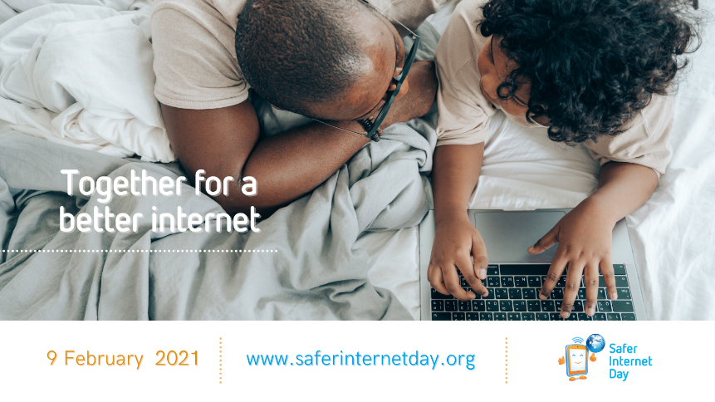  Image name: SID2021_Twitter_Parents
Help us spread the word about #SaferInternetDay! Show the world that you’re a #SID2021 supporter by adding a Twibbon to your profile – bit.ly/SID2021_Twibbon | 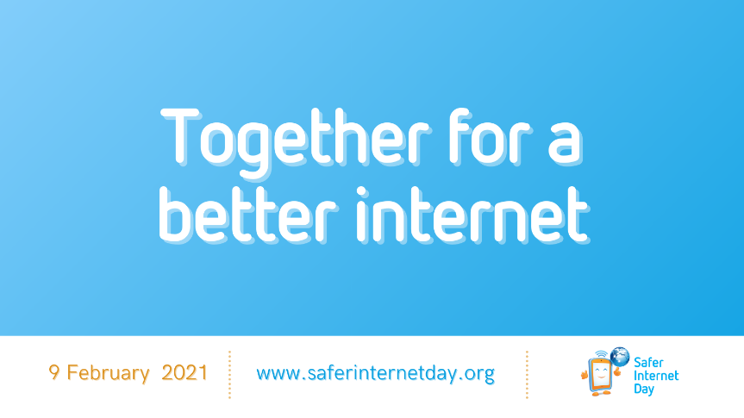  Image name: SID2021_SloganBlue

C – Countdown to Safer Internet Day 2021
From Tuesday, 2 February 2021 to Monday, 8 February 2021
Please note – You are kindly asked to refrain from publishing these visuals before the publication date mentioned for each item.
Suggested post | Accompanying visual
Can you believe it? #SaferInternetDay is next week!  Stay up to date with the range of exciting activities about to take place across the globe for a better internet.  Keep an eye on www.saferinternetday.org! | Image name: SID2021_Countdown_1Week  Publication date: Tuesday, 2 February 2021, 11:00 AM CET
Six days to go until #SaferInternetDay!  How will you contribute to a better internet? One simple way of doing so is to spread the word about #SID2021 and show your support on social media!  Find out how you can do so at www.saferinternetday.org/join | Image name: SID2021_Countdown_6Days  Publication date: Wednesday, 3 February 2021, 11:00 AM CET
Five days left before millions of change-makers from over 170 countries join in a global movement, together for a better internet, for #SaferInternetDay!  Will you be one of us?  Visit www.saferinternetday.org/join to find out the many ways in which you can contribute! | Image name: SID2021_Countdown_5Days  Publication date: Thursday, 4 February 2021, 11:00 AM CET
Only four days left before the big day!  Next week, we’ll be millions across the globe, joining forces together for a better internet and marking #SaferInternetDay through thousands of events and activities.  And you, how will you celebrate? Find ideas at www.saferinternetday.org/join | Image name: SID2021_Countdown_4Days  Publication date: Friday, 5 February 2021, 11:00 AM CET
Can you believe in only three days, we’re celebrating #SaferInternetDay?  Share your plans with us! Let us know how you’ll be marking the day in your school, company, organisation, family and community!  More tips on getting involved in #SID2021, at www.saferinternetday.org/join | Image name: SID2021_Countdown_3Days  Publication date: Saturday, 6 February 2021, 11:00 AM CET
In two days, for #SaferInternetDay, we’ll be millions of individuals, united across the world with one goal: creating a better internet!  Will you be one of us?  Find out how your contribution can make a difference at www.saferinternetday.org | Image name: SID2021_Countdown_2Days  Publication date: Sunday, 7 February 2021, 11:00 AM CET
Are you ready for tomorrow?  On #SaferInternetDay, we’ll be millions of change-makers, joining forces together for a better internet across over 170 countries!  Discover the wealth of (online) events and activities you can join at www.saferinternetday.org/in-your-country | Image name: SID2021_Countdown_1Day  Publication date: Monday, 8 February 2021, 11:00 AM CET

On Facebook
A – Dissemination of Safer Internet Day top tips
From Monday, 25 January 2021 to Tuesday, 9 February 2021
Suggested post |  | Accompanying visual
These past five years, cyberbullying has been the most frequently reported issue to @saferinternet helplines.  This @SaferInternetDay, let’s join together for a better internet and put an end to it. bit.ly/3ofCHkV |  | 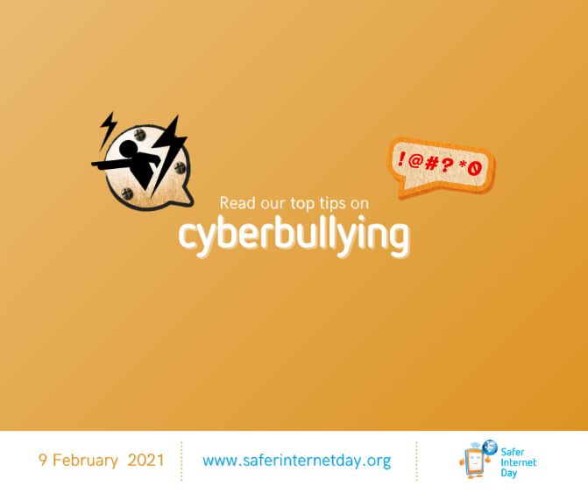  Image name: SID2021_Facebook_Cyberbullying
Too many children and young people encounter inappropriate content online, which risks harming their development.  With @SaferInternetDay coming up, there's no better time to dive into our explainer and resources on the topic: bit.ly/3c60ZeB |  | Image name: SID2021_Facebook_Inappropriate
In our ever-more digitalised societies, curating your online reputation is becoming imperative.  @SaferInternetDay is the perfect opportunity for you to learn how to do so like a pro!  Discover our topical explainer at bit.ly/3ohCEoG |  | 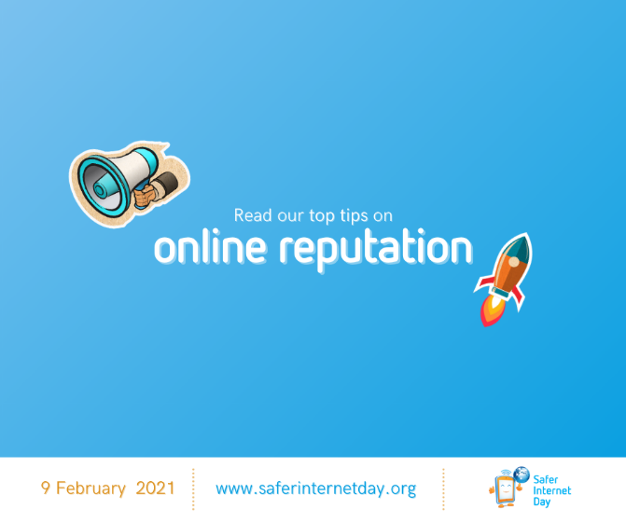  Image name: SID2021_Facebook_OnlineReputation
Sexting can pose a serious challenge to children and young people as it can potentially expose them to the non-consensual sharing of intimate images with a wider audience.  This @SaferInternetDay season, discover our safety tips at bit.ly/3qJnTN9 |  | Image name: SID2021_Facebook_Sexting
Sextortion refers to the sexual coercion and extortion of children and young people online, for predatory or financial motives.  With @SaferInternetDay approaching, now is the time to educate yourself on the topic and find some tips for dealing with it at bit.ly/3iHbyGh |  | Image name: SID2021_Facebook_Sextortion
There are many online challenges out there, and while most are fun and harmless, some have turned out to have tragic consequences.  As @SaferInternetDay is approaching, learn more about this phenomenon and the risks it poses in our topical explainer: bit.ly/3odBoD4 | 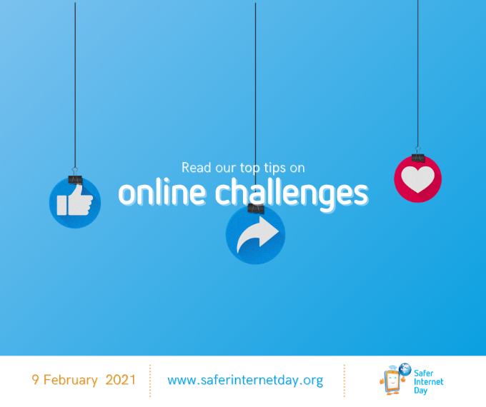  Image name: SID2021_Facebook_OnlineChallenges

B – Dissemination of Safer Internet Day promotional assets
From Monday, 25 January 2021 to Tuesday, 9 February 2021
Suggested post | Accompanying visual
On Tuesday, 9 February 2021, for @SaferInternetDay, we’ll be millions, joining forces around the globe, together for a better internet!  The SID promotional video is available with subtitles in 25+ languages – go watch it now at youtu.be/M03BJFjBM3w | YouTube thumbnail of the SID video
✅ What is @SaferInternetDay?  ✅ What does it stand for?  ✅ How can we all play our part for a better internet?  Find answers to all your questions in our SID 2021 infographic – view it in full resolution at (LINK) | Image name: SID2021_Infographic
@SaferInternetDay is an annual celebration observed in over 170 countries.  Every February, we come together for a better internet, raising awareness of the online issues that matter to us.  Learn more about SID at bit.ly/2KrwQLp | Image name: SID2021_Facebook_Kids
We all play a part in creating a better internet.  With @SaferInternetDay coming up, let’s review the state of online safety in 2021, and explore why individual action is key in changing the online world for the better.  Read our piece on the topic at bit.ly/2YfBH5z | 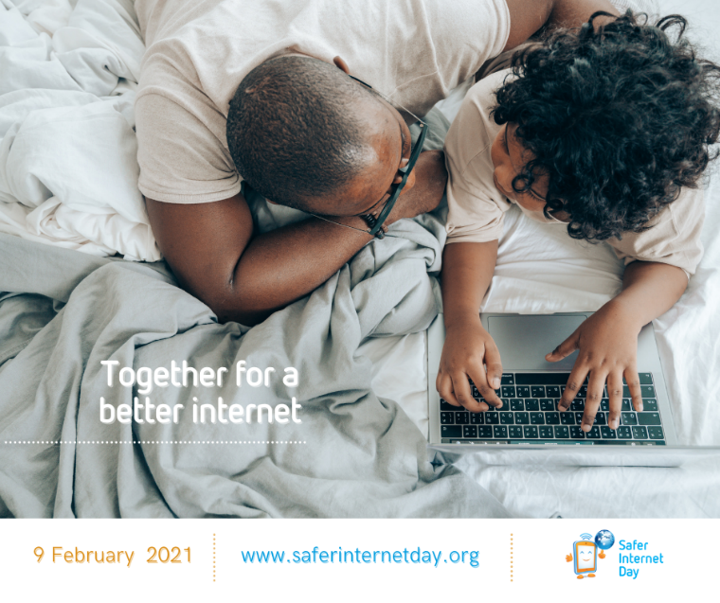  Image name: SID2021_Facebook_Parents
Help us spread the word about @SaferInternetDay! Show the world that you’re a SID 2021 supporter by adding a Twibbon to your profile – bit.ly/SID2021_Twibbon | 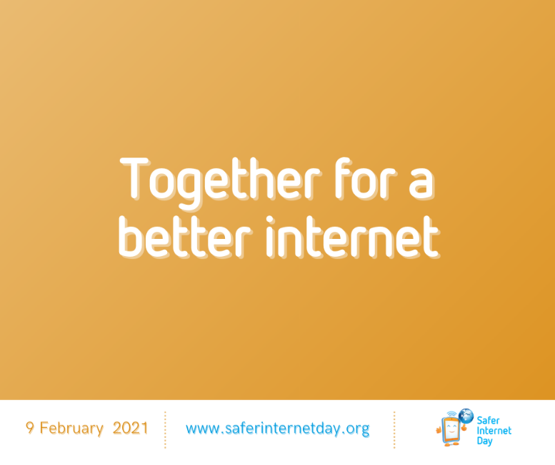  Image name: SID2021_Facebook_SloganOrange

C – Countdown to Safer Internet Day 2021
From Tuesday, 2 February 2021 to Monday, 8 February 2021
Please note – You are kindly asked to refrain from publishing these visuals before the publication date mentioned for each item.
Suggested post | Accompanying visual
Can you believe it? @SaferInternetDay is next week!  Stay up to date with the range of exciting activities about to take place across the globe for a better internet.  Keep an eye on www.saferinternetday.org! | Image name: SID2021_Countdown_1Week  Publication date: Tuesday, 2 February 2021, 11:00 AM CET
Six days to go until @SaferInternetDay!  How will you contribute to a better internet? One simple way of doing so is to spread the word about SID 2021 and show your support on social media!  Find out how you can do so at www.saferinternetday.org/join | Image name: SID2021_Countdown_6Days  Publication date: Wednesday, 3 February 2021, 11:00 AM CET
Five days left before millions of change-makers from over 170 countries join in a global movement, together for a better internet, for @SaferInternetDay!  Will you be one of us?  Visit www.saferinternetday.org/join to find out the many ways in which you can contribute! | Image name: SID2021_Countdown_5Days  Publication date: Thursday, 4 February 2021, 11:00 AM CET
Only four days left before the big day!  Next week, we’ll be millions across the globe, joining forces together for a better internet and marking @SaferInternetDay through thousands of events and activities.  And you, how will you celebrate? Find ideas at www.saferinternetday.org/join | Image name: SID2021_Countdown_4Days  Publication date: Friday, 5 February 2021, 11:00 AM CET
Can you believe in only three days, we’re celebrating @SaferInternetDay?  Share your plans with us! Let us know how you’ll be marking the day in your school, company, organisation, family and community!  More tips on getting involved in SID 2021, at www.saferinternetday.org/join | Image name: SID2021_Countdown_3Days  Publication date: Saturday, 6 February 2021, 11:00 AM CET
In two days, for @SaferInternetDay, we’ll be millions of individuals, united across the world with one goal: creating a better internet!  Will you be one of us?  Find out how your contribution can make a difference at www.saferinternetday.org | Image name: SID2021_Countdown_2Days  Publication date: Sunday, 7 February 2021, 11:00 AM CET
Are you ready for tomorrow?  On @SaferInternetDay, we’ll be millions of change-makers, joining forces together for a better internet across over 170 countries!  Discover the wealth of (online) events and activities you can join at www.saferinternetday.org/in-your-country | Image name: SID2021_Countdown_1Day  Publication date: Monday, 8 February 2021, 11:00 AM CET

What’s next?

Your go-to sources of information for all things related to Safer Internet Day are www.saferinternetday.org and the SID channels on Twitter and Facebook – make sure to keep an eye on those regularly, and please support us by liking, sharing, retweeting the content.
Equally, keep an eye out for issue n°3 of the SID social media plan, which will contain social media content for the day of SID itself – Tuesday, 9 February 2021. This latest plan will be shared on the day before, Monday, 8 February 2021.
Once again, the SID Coordination Team would like to warmly thank everyone who is supporting and engaging with the Safer Internet Day 2021 campaign. We are looking forward to seeing your plans unfold on the big day. Together for a better internet!

